Spot Removal Technique Guide

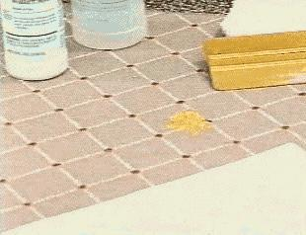
It is not always necessary to clean an entire carpeted area to remove a small spot or spill. This tutorial will demonstrate the technique we use as professionals to remove spots.
If the spot is still moist, blot as much as possible, dabbing lightly with a clean white towel or a paper towel. Scrape off any solids with a spatula. If the spot is dry, loosen with a spotting spatula and then thoroughly vacuum.
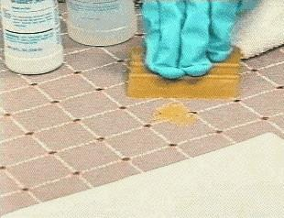
Always pre-test the surface to be cleaned. Apply the cleaning solution to an inconspicuous area of the carpet. If after 5 minutes the carpet color transfers to the towel, discontinue its use and try another solution.
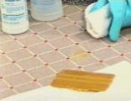

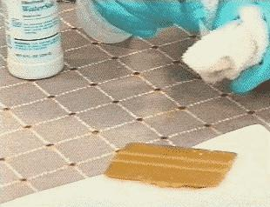
When taking out spots ALWAYS use a clean white towel. First apply the spotting solution to the towel and then blot it onto the spot.

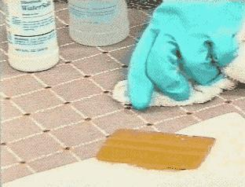
Then place the towel on the carpet. Work from the outside of the spot to the inside, using a blotting motion. Repeat as long as the spot is transferring to the towel. Never rub the area, as this will permanently damage the carpet fiber.
Always treat spots as soon as possible. If the spot dries it may lock into the dye sites of the carpet fiber. If that happens the spot will likely be permanent. Time is of the essence, so the sooner a spot is attended to, the better.
